Small Changes to Cloud Interface

Three small changes:

1. Pls. replace Good/Bad banner with this

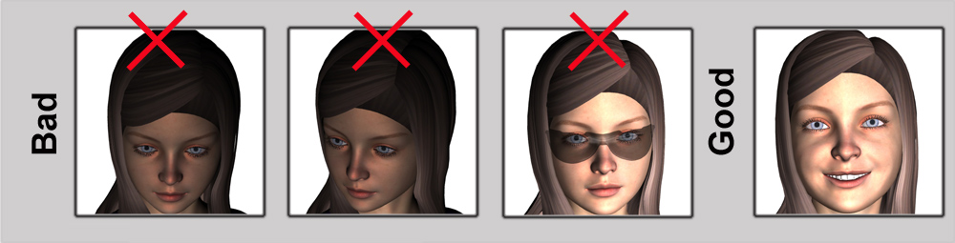

1. Eliminate button for Age/Weight

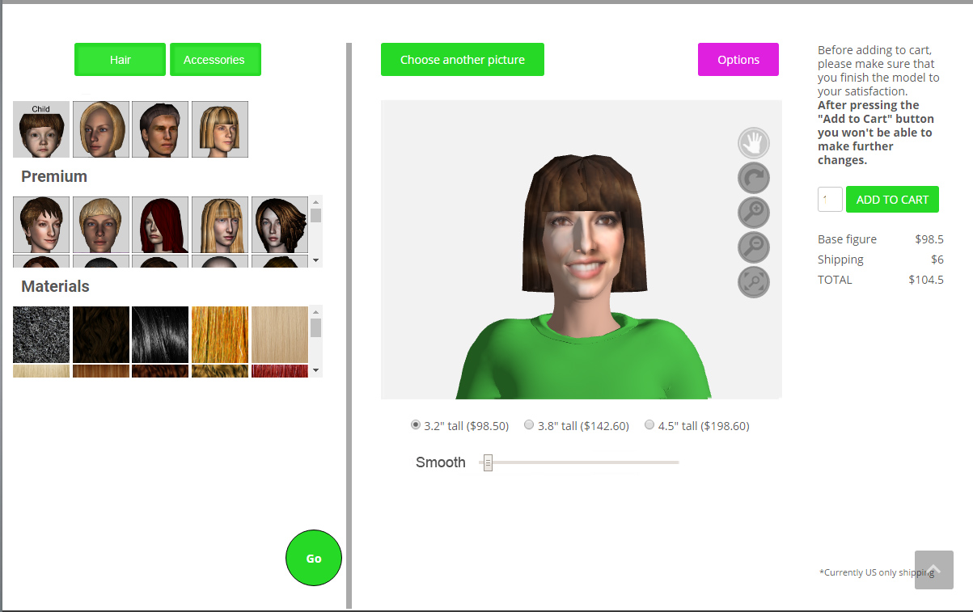

1. Take Smooth function from the Age tab and place it under the size buttons (as shown). Please have a 40% smooth as default and apply 40% smooth automatically. User can increase or decrease via slider.